Communications Toolkit

NCSEAD Case Study: Putting It All Together
The following content promotes the brand new case study by the Aspen Institute’s National Commission on Social, Emotional, and Academic Development (NCSEAD), entitled “Putting It All Together.” Please share with your supporters via email and social media. You can download a full PDF of the case study here.

Case Study Description
A new case study from the Aspen Institute National Commission on Social, Emotional, and Academic Development explores how schools and school districts across the country are integrating social, emotional and academic development (SEAD) into their K-12 classroom curricula. From a D.C. school embedding collaboration, critical feedback, and leadership skills in its lessons across subject areas to the “growth mindset” math program in the San Francisco Unified School District, the case study highlights promising strategies for leveraging the curriculum to simultaneously build students’ social, emotional, and academic skills.
The report is the first in a series that will examine challenges, opportunities, and key lessons for re-envisioning what success looks like in our schools. The series serves to help drive a greater conversation about how students learn and how to bring the best ideas and practices to all schools and students.

Twitter (Some posts share individual graphics)
See firsthand how schools are maximizing learning by addressing social, emotional, and academic development. http://bit.ly/2inwUgj #SEAD
New case study highlights how learning is inherently social and emotional. http://bit.ly/2inwUgj #SEAD #SEL
See how incorporating #SEL into the academic curriculum is helping #teachers prepare students for life. http://bit.ly/2inwUgj [Graphic 1] #SEAD
Academic achievement has always required #SEL understanding. http://bit.ly/2inwUgj [Graphic 2] #SEAD
Academic learning and #SEL are complementary and support each other. http://bit.ly/2inwUgj [Graphic 3] #SEAD
Commission Co-chair @TimShriver on the power of #teachers and curricula that address social, emotional, and academic skills. http://bit.ly/2inwUgj [Graphic 4] #SEAD
Students grow when they learn to take risks, but they need to have a supportive classroom culture. http://bit.ly/2inwUgj [Graphic 5] #SEAD

Facebook (Each post shares individual graphic)
New case study shows how incorporating #SEL into the academic curriculum is helping teachers prepare students for life. http://bit.ly/2inwUgj [Graphic 1]
New case study from @The Aspen Institute’s National Commission on Social, Emotional, and Academic Development shows the power of truly integrating #SEL into an academically rigorous curriculum. http://bit.ly/2inwUgj [Graphic 2]
Read how schools are maximizing learning by addressing students’ social, emotional, and academic development. http://bit.ly/2inwUgj [Graphic 3]

Graphics

Graphic 1
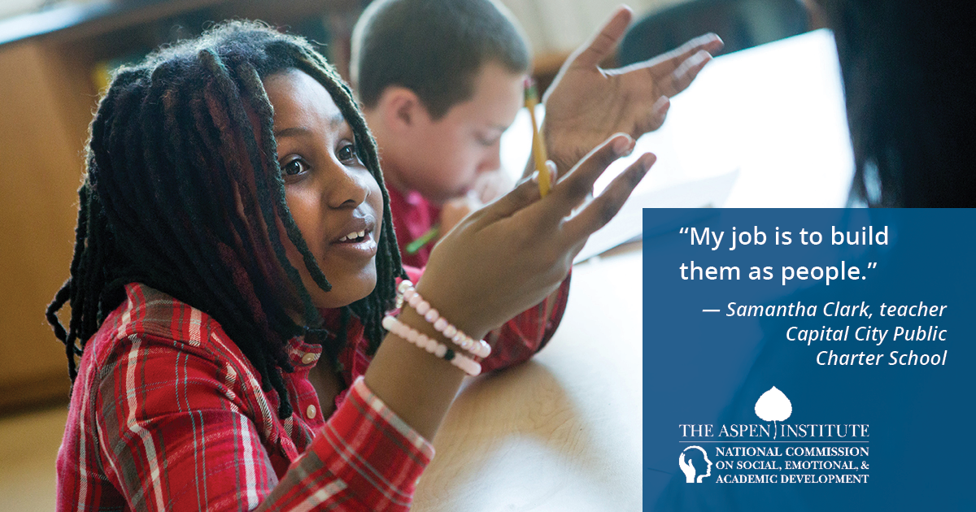

Graphic 2
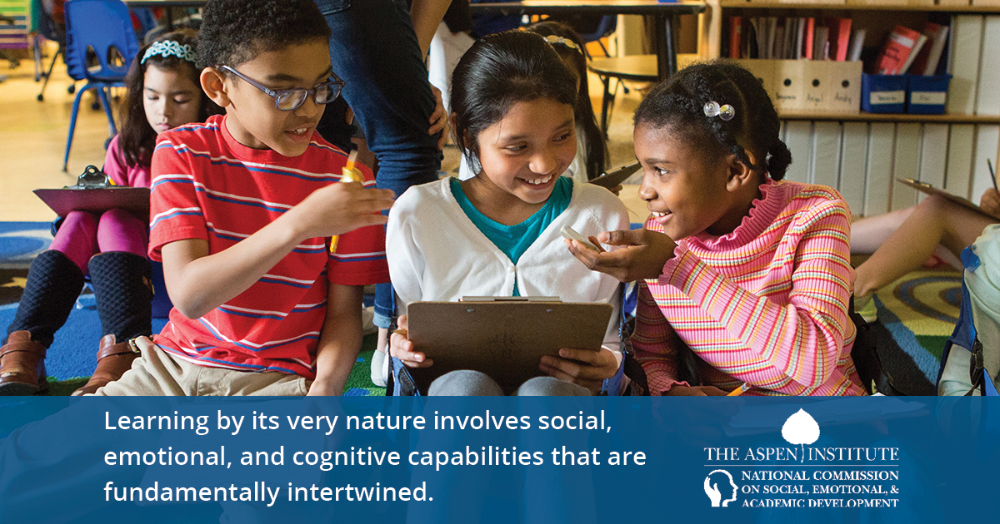

Graphic 3
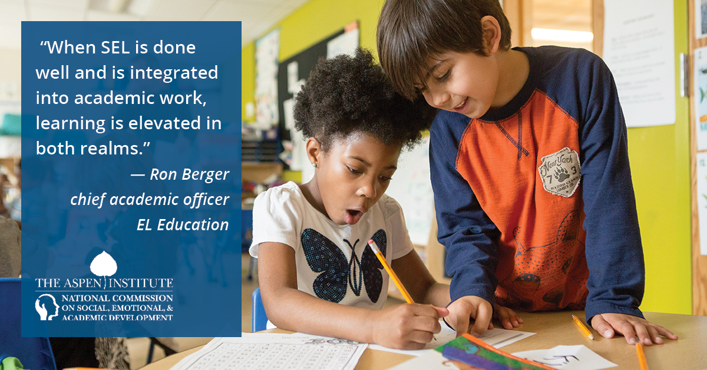

Graphic 4
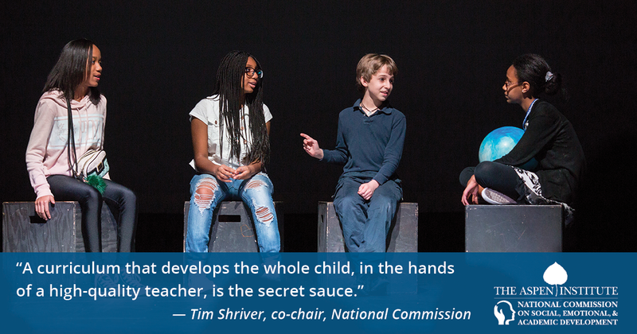

Graphic 5 