Practice Agenda that Supports a Shared Vision for Students’ Social, Emotional, and Academic Development

Ron Berger, Sheldon Berman and Josh Garcia

August 30, 2018

Introduction
On the front lines of education, students, families, and educators are demanding a more balanced approach to our vision of learning: One that recognizes learning is always social, emotional, and academic, and these strands cannot be teased apart. One that goes beyond test scores in reading and mathematics to an authentic picture of what it means to be a successful graduate—with the academic and social skills and good character to become a positive, contributing member of society with a productive and fulfilling life. One that reflects what all families actually want for their children.
The case for change is clear and compelling. More than two decades of research across a wide range of disciplines—developmental psychology, economics, and learning and brain science—demonstrates that learning has social, emotional, and academic dimensions. We now know that students will make far more progress academically when they’re given the opportunity to learn in environments where these skills are recognized as mutually reinforcing and central to learning. We also know that these skills, habits, and attitudes grow over time. And there already exist a range of programs and approaches to intentionally foster children’s social, emotional, and academic development that are achieving results, increasing students’ academic achievement, but also their ability to get along well with others, persist at hard tasks, and believe in themselves as effective learners and individuals. Young people with stronger social, emotional, and academic competencies are more likely to enter and graduate from college, succeed in their careers, have positive work and family relationships, better mental and physical health, reduced criminal behavior, and to become engaged citizens. Similarly, employers recognize that it doesn’t matter how much workers know if they can’t work well in teams, communicate clearly, and grapple with difficult problems.
Skills and Competencies for Social, Emotional, and Academic Development
The evidence base demonstrates that there are a variety of skills, attitudes, and values that are embedded in and support learning. These generally fall into three broad categories: (1) skills and competencies; (2) attitudes, beliefs, and mindsets; and (3) character and values.

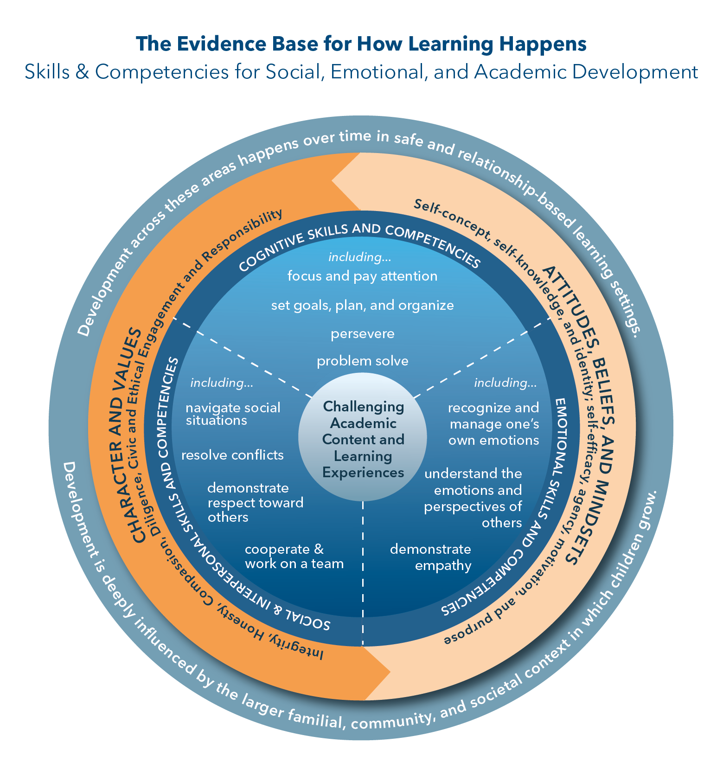

Skills and competencies – shown in the center of the figure above – represent approximately a dozen specific behaviors that decades of research and practice indicate are important. Though they are interrelated, these can be organized into three areas: cognitive, social, and emotional.
- Cognitive skills and competencies underlie the ability to focus and pay attention; manage distractions; set goals, plan, and organize; and persevere and problem solve.
- Social and Interpersonal skills and competencies enable children and youth to read social cues and navigate social situations; negotiate and resolve conflicts with others; cooperate and work effectively on a team; communicate clearly; engage in positive and respectful relationships; and demonstrate respect and empathy toward others.
- Emotional skills and competencies help children and youth recognize and manage their emotions, understand the emotions and perspectives of others, make responsible decisions, and cope with frustration and stress.

Importantly, this set of skills and competencies develop and are used in dynamic interaction with attitudes and values – shown in the second ring in the figure to the right. Attitudes, Beliefs, and Mindsets includes children and youth’s attitudes and beliefs about themselves, others, and their own circumstances. Examples include self-concept, agency and self-efficacy, and motivation and purpose. These types of attitudes and beliefs are a powerful influence on how children and youth interpret and respond to events and interactions throughout their day. Character and Values represent ways of thinking and habits that support children and youth to work together as friends, family, and community and encompasses understanding, caring about, and acting on core ethical values such as integrity, honesty, compassion, diligence, civic and ethical engagement, and responsibility.
How This Translates to Mastery of Academic Content and Knowledge
When learning environments recognize these skills as mutually reinforcing and central to learning, children are better able to master academic content and knowledge. We also know that these skills and competencies grow over time and can be explicitly taught and modeled. When children and youth possess a full array of social, emotional, cognitive, and academic skills, they are best equipped to prosper in the classroom, perform in the workplace, and succeed in life, as contributing and productive members of society.
What This Looks Like in Schools and Communities: The Elements of Success
In the past two years, the National Commission on Social, Emotional, and Academic Development has visited schools and programs across the country that are putting this research and practice into action. These learning settings have developed a broader vision of student success, and they have supported it by focusing on three essential elements:
- First, children and youth are intentionally taught social, emotional, and cognitive skills—such as how to resolve conflicts and work in a team, recognize and manage emotions, and plan and manage their time. Today, many programs and approaches that intentionally develop such skills are showing promising results.
- Second, students are asked to exercise these skills through learning academic content and in their interaction with peers and adults throughout the day. How we learn depends on experience and use. It’s not enough to teach specific skills if students do not have opportunities to develop and apply them on a regular basis. For example, if “mathematical courage” is explicitly taught and valued, students are emboldened to take positive risks—by raising their hands, asking questions, making mistakes, presenting their thinking, considering others’ perspectives, and receiving suggestions from their peers—all of which enhance their learning of mathematics. Opportunities to connect with and exercise the full complement of social, emotional, and cognitive skills exist not only in academic subjects, like mathematics or reading, but also in enrichment activities, such as sports, music, and the arts, and in how students and adults interact with each other, whether in the hallways or in the cafeteria.
- Third, the learning environment is physically and emotionally safe and fosters meaningful relationships among and between adults and students. For example, students help develop classroom and school norms that are followed by everyone in the building. And there are structures and practices in place, like morning meetings, teams of teachers that share a cohort of students, mentorship programs, and advisory groups that enable every student to be known well by at least one adult. A respectful learning environment models and reinforces the development of students’ social, emotional, and cognitive skills throughout the school day, not just in a single program or lesson. Respectful learning environments in schools also model and reinforce the norms set and followed by other learning settings with which they partner.
As illustrated below, these three elements are the hallmarks of a learning experience where children and youth are engaged, have a sense of ownership, and find purpose in their learning. They also learn to see themselves as contributing members of their school and broader community. Most important, they are likely to grasp difficult academic content and concepts, because the instructional practices and learning environments reflect what we know about how people actually learn.

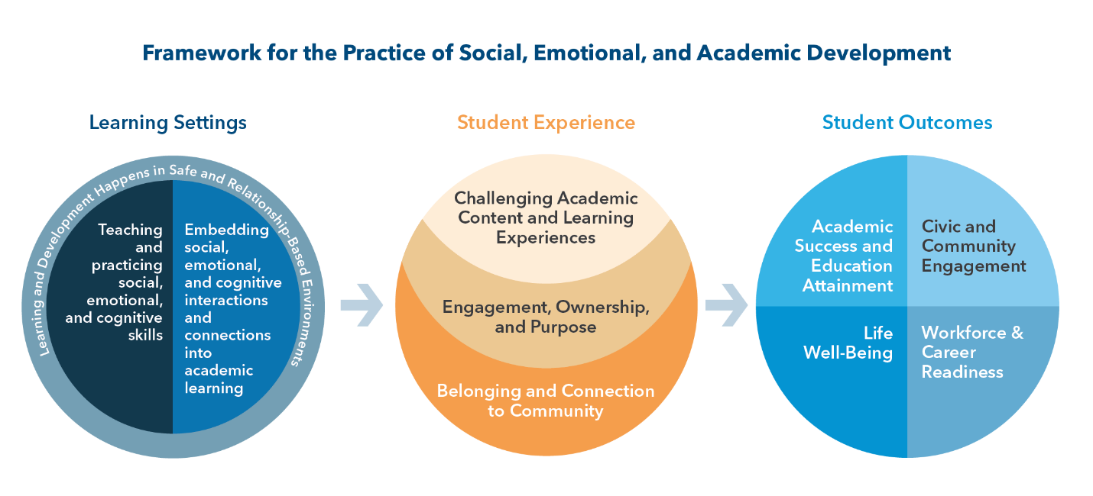

Many argue that school is not the place to build social and emotional skills and habits—to foster good character—that this is the realm of families or faith-based institutions. But given the integrated nature of learning, schools have an important role to play. The social environment of the school communicates our expectations of how people will relate to and treat each other so we need to construct environments that model the behaviors we want to foster in students. We can choose to take on this work intentionally and meaningfully in schools, to do it well, or ignore it and do it poorly.

We must build on the strengths of students and families and work collaboratively with them to build positive learning communities. In the past, an inordinate focus on deficits has led schools to try to “fix” students, particularly students of color, students with special needs, and students living in poverty. This mindset fails to recognize and capitalize on students’ and families’ strengths and assets. As educators, we must build on students’ existing social, emotional, and academic competencies and work to create environments where they can thrive, targeting additional supports where needed.

We must recognize that learning is fundamentally developmental, occurs over time, is influenced by one’s lived experiences, and is best facilitated through relationships. This not only applies to students, but also to the adults charged with leading student learning. School leaders and teachers will not respond well to top-down mandates to “deliver” a new curriculum and change their instructional approach if it does not make sense to them and they do not believe in it. The professional learning community of a district or school needs to be founded on respectful relationships where educators can work collaboratively to consider and adopt new programs and approaches, learn together, and effect change over time with a shared vision.

We must reach beyond the schoolhouse to embrace the broader community and to recognize both the formal and informal opportunities for learning and enrichment that fully support young people in their development. Community organizations also are vital partners in creating multi-tiered systems of support that can help address real challenges in children’s lives—including physical and mental health problems, learning disabilities, discrimination, violence, homelessness, and hunger.

PLEASE NOTE – As we use the term educator throughout our recommendations, we include the following individuals unless otherwise specified: classroom teachers; school administrators and district-level staff; school librarians; paraprofessionals; specialized instructional support personnel (including but not limited to counselors, social workers, psychologists, and other related services personnel); non-instructional school staff members (including but not limited to custodial staff, cafeteria staff, and school office staff); as well as youth development professionals working in and out of schools. Additionally, as we use the term student, we include children in grade levels PreK-12, spanning all physical, emotional, social, psychological, and cognitive abilities; all socioeconomic, regional, and familial backgrounds; all races, ethnicities, and nationalities; all genders, identities, and orientations; and all religious and spiritual affiliations.

RECOMMENDATIONS FOR A PRACTICE AGENDA
There is abundant evidence that when districts and schools explicitly and meaningfully commit to focusing on the social and emotional development of students as a central part of their academic growth, the academic success and the welfare of students rise powerfully together. And, while social and emotional competencies cannot in and of themselves prevent school or community violence and bullying, they do constitute a significant and viable strategy for helping staff and youth develop the character, decision-making skills, and interpersonal relationships that can make schools and communities physically and emotional safer for all.
The Commission’s recommendations highlight schools as a central opportunity for the integration of social, emotional, and academic development. However, creating learning environments in schools that deeply integrate the social, emotional, and academic aspects of learning and development can no longer be viewed as simply the responsibility of schools alone. We must shift to a vision of shared responsibility in which all voices and capacities within the community—including social workers, counselors, mental health providers, youth serving organizations, and civic and faith-based organizations— join forces to support our children’s learning and development.
Families, after-school and youth-serving organizations, and the community—through their voices, their priorities, their allocation of time and resources, and their expertise—provide a major source of expanded capacity to support the work of educators in schools and classrooms. In this way, capacity building becomes a joint venture across all the individuals, organizations, and institutions that serve young people. In short, the integrated nature of learning requires an integrated, community-wide approach to supporting children’s education.
There also is a need for field-building – to connect different disciplines and frames, and to call on educators, leaders in youth-serving organizations, and policymakers and elected officials across the PreK-12 education ecosystem (see below) to embrace an integrated approach to educating the whole student.

Pre-K-12 Education Ecosystem

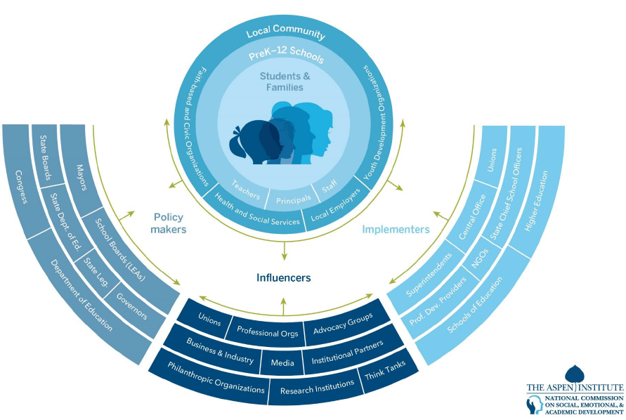

This effort should not be viewed as a new initiative. Rather, it is a rebalancing of PreK-12 education to focus on the broad set of social, emotional, and academic skills and competencies that each and every student needs to be a lifelong learner, productive worker, and engaged citizen. Schools and youth-serving organizations along with their community partners already have significant work underway that can and should be leveraged and amplified; we provide some of these compelling examples to illuminate our practice recommendations.
Our practice recommendations seek to provide a framework through which key voices within schools and communities—students, teachers, families, after-school and youth-development organizations—can work together to create learning environments that foster the comprehensive development of all young people.
Our theory of action synthesizes the Commission’s critical learnings and understanding of the education landscape following school site visits; consensus-building processes with leading researchers and educators; as well as panels and discussions with teachers, students, families, and community leaders across the country who reflect diverse backgrounds, beliefs, and lived experiences. Grounded in the evidence on how learning happens and what we have seen in action in classrooms and other school spaces, these efforts may not—indeed, should not—look the same everywhere because they need to be developed in partnership with young people, their families, and their communities. Not only does practice need to build on what already exists locally, but we also need to grow and deepen our understanding of how these foundational skills and competencies develop over time and how best to support their growth.

I. Set A Clear Vision
Articulate and prioritize a clear vision that develops the whole child and reflects the interconnected social, emotional, and academic dimensions of learning as the way learning happens.

II. Teach Students Social, Emotional, and Cognitive Skills Explicitly and Embed Them in All Academic Learning

Use evidence-based practices that intentionally develop social, emotional, and cognitive competencies in all young people. Provide regular opportunities throughout the day to integrate these competencies with academic content in all areas of the curriculum.

III. Create Safe and Supportive Learning Environments in School and Community Settings
Create child- and youth-centered learning environments that are physically and emotionally safe, that respect all cultures and serve people equitably, and that foster meaningful relationships among and between adults and young people.

IV. Build Adult Capacity
Provide opportunities for school faculty and staff, families, after-school and youth development professionals, and future professionals still in university pre-service programs to learn to model and teach social, emotional, and academic skills to young people across all learning settings, both during and out of school.

V. Work Together as Advocates and Partners for Student Learning
Continue to embrace families and align community organizations, higher education institutions, and professional associations as partners to create a cohesive PreK-12 education ecosystem that supports students holistically.
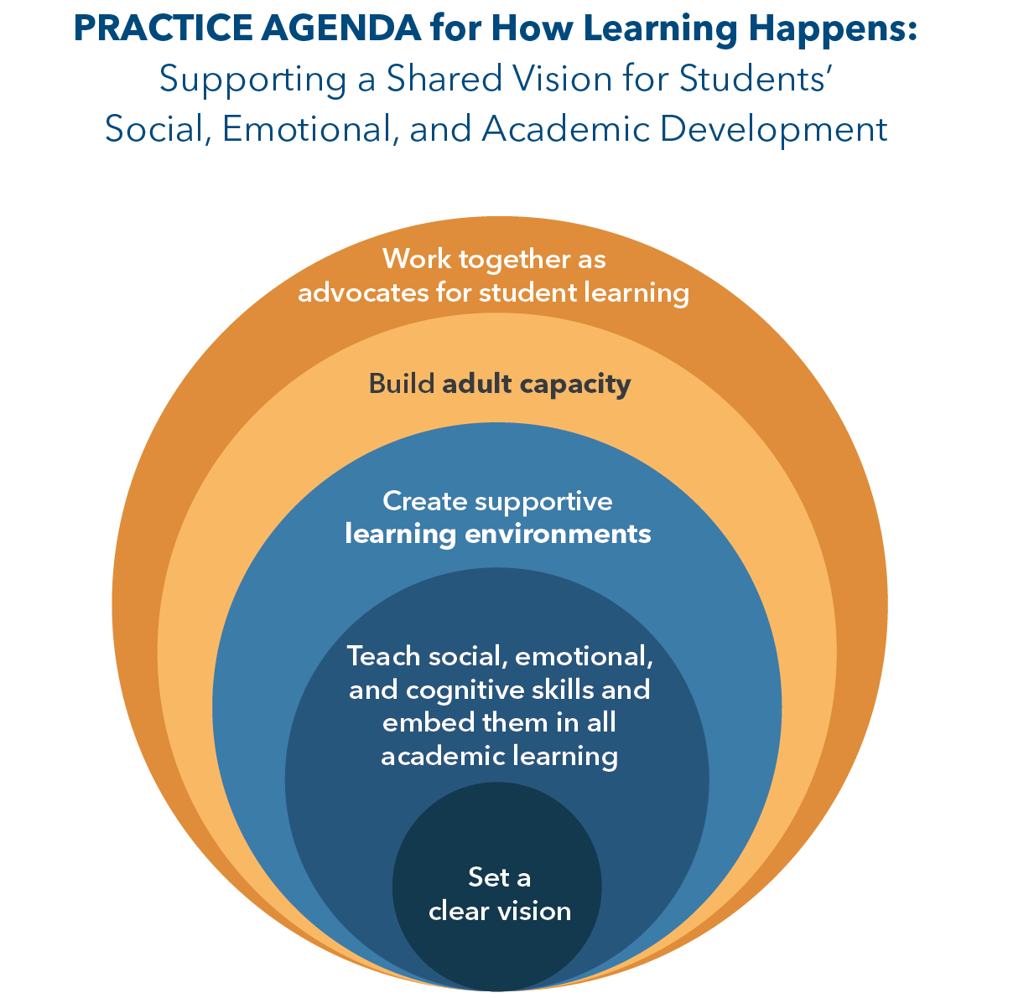

Recommendation I: Set A Clear Vision. District, school, and youth development leaders—in partnership with students, teachers, families, youth-serving professionals, and the local community—should articulate and support a clear vision for the social, emotional, and academic outcomes for student learning that they believe will lead to a successful life for all students.
Many, if not most, of our Nation’s most successful schools are distinguished by having a clear shared vision that permeates the school culture: you know right away what this school is about, and the staff are on the same page. Students fortunate enough to attend such a school can experience a coherent set of messages across classrooms and grade levels; they do not need to hope to get “the right teacher” in order to find the guidance they seek. Even more powerful is when the vision of the school is informed by and supported by parents and youth-serving organizations in the community. When that is the case, the students’ whole lives become more coherent.
It is our charge as adults—particularly educational and community leaders—to work together across school staffs and across the community to forge common language for the outcomes we hope students will achieve. This is not an easy process. There will need to be compromises in ideas and language to build this shared vision of what we value. But the hard work is worth it. The more we can be coherent and clear about what we are aiming for, the more coherent and clear our students’ growth as scholars and people can be.

Strategy: Align Around a Shared Vision of Student Success. Schools, districts, and youth development organizations can align their visions, missions, values, and corresponding strategic action plans and budget priorities with a profile of student success that explicitly incorporates social, emotional, and academic development. This vision of successful youth development can be co-constructed and shared broadly to facilitate the continuity of strategies across the school day, after school, on evenings and weekends, and during the summer.

The education sector is replete with disparate and fragmented initiatives. Alignment around a central vision creates clarity and coherence in the system, which enables principals and teachers to prioritize and focus their work. As systems strive for greater alignment, it’s important that they take the voices of teachers, youth development professionals, and students into account because of their first-hand knowledge of how school, district, and organizational policies affect them and what they need in order to succeed.

District, school and youth development leaders can:
- Develop vision, mission, core value, and belief statements that combine social, emotional, and academic outcomes
- Include specific targets in their strategic plans to ensure that these goals are a priority.
- Develop a leadership structure that clearly identifies responsibility and support for this work at district, school, and organization levels.
- Ensure that these goals are priorities across the board: in human capital, curriculum and assessment, professional development, teaching and learning, support programs in English language learning, special education, gifted and talented education, Title I, etc., and in internal and external partnerships with families, community organizations, businesses, and postsecondary educational institutions.
- Communicate—internally and externally, through many avenues and on an ongoing basis—the value and importance of social, emotional, and academic development.
As an example of alignment around a shared vision, Andover Public Schools in Massachusetts has incorporated social, emotional and academic development throughout the elements of its theory of action. The district’s vision declares, “We will prepare all students to be connected and compassionate citizens who contribute to a diverse and global society.” Part of Andover’s mission is to “provide every student with opportunities and support to demonstrate … an appreciation of self, empathy toward others, a sense of responsibility….” One of the district’s goals is to “create safe, caring, and culturally responsive classrooms and schools, and partner with families and the community to support students’ academic growth and their social, physical and emotional wellbeing.” Andover’s staff members keep these concepts in mind as they implement strategic plans to move their students forward—and as they model the very behaviors and thought processes they want the students to develop over time.

Strategy: Identify Learning Objectives. Schools and districts can identify developmentally appropriate and culturally responsive social, emotional, and academic learning objectives and align them across youth-serving organizations to provide a coherent learning progression from PreK through grade 12.

Social, emotional, and academic skills develop and change over time, beginning in the earliest years and continuing through childhood, adolescence, and even adulthood. This developmental progression, in which some skills contribute to the development of more complex skills later on, points to different stages of education when different social, emotional, and academic competencies become more salient. This suggests that certain skills should be taught before others, within specific grade or age ranges, and that instruction should be developmentally sequenced and age-appropriate. Thus, young children need support to identify and manage their emotions and focus their attention. During adolescence the development of these skills continues, again within specific supports that foster their development. But other skills begin to emerge, including self-efficacy, agency, and a sense of purpose, when adolescents can deeply explore and expand their personal interests and make positive contributions to their schools and wider communities. Of course, students vary greatly in how they progress and develop and this progression needs to honor and be responsive to young people’s cultures, backgrounds, languages, and achievements.
District, school, and youth development leaders can:
- Implement equity policies that examine and monitor how differences in culture, race, ethnicity, and background affect students’ social, emotional, and academic success.
- Incorporate standards for social and emotional skills within existing academic standards or alternatively, identify standards that specifically target social and emotional competencies.
- Adopt multi-tiered systems of support for learning that address the needs of all students, including those with disabilities and students who need additional academic interventions or individualized help to meet social, emotional, and academic learning targets.
In Montgomery County Public Schools, in Maryland, the Office of School Support and Improvement has established an Equity Initiatives Unit in an effort to close the racial achievement gap and eliminate racial predictability in student achievement. Educators are provided with “The Short Takes,” a companion instructional tool to the Equitable Classroom Practices document. Each of the short takes elaborates on one of 27 specific, observable teacher behaviors that communicate high expectations to students by defining the practice, summarizing key points in the research, and providing suggestions on what teachers can do to demonstrate the equitable practice to all students. The short takes are intended to support staff reflection and discussion about how educators can be more conscious of and purposeful in incorporating best practices to promote equitable instruction for African-American and Hispanic students. The tool is designed to provide a brief professional development experience suitable for an individual, a small group, or an entire staff. Many of the short takes are interactive and include links to additional sites for more detailed information. Actual classroom video demonstrations of the equitable practices are included as well. Additionally, the Equity Initiatives Unit has a staff of equity team members to support, coach, consult, and collaborate with schools and offices to design and implement efforts to address equity and cultural competency.
Strategy: Facilitate Continuous Improvement. Districts, schools, and youth-serving organizations can use measures to track progress and to facilitate capacity building and continuous improvement for the integration of social, emotional, and academic development.
Measures such as climate and culture surveys and indicators of whether young people are on track to graduate provide an indication of the types of learning environments we are offering students and can help to monitor progress and to inform decision making and action. Schools and districts can work with youth development organizations and other out-of-school settings to learn from one another’s history and experience in measuring program quality in order to foster better alignment across sectors. Individual measures of students’ social and emotional development can be considered for purposes of supporting student growth and continuous improvement, rather than for individual or school accountability.

District, school, and youth organization leaders can:
- Identify specific criteria for high-quality learning environments that are reflected in multiple measures inside and beyond the classroom.
- Clearly and intentionally communicate these learning environment criteria to school leaders, classroom and youth development educators, as well as families and students.
- Employ measures such as climate and culture surveys involving students, families and staff, and school quality assessments to assess progress toward climate and culture goals.
• Review social, emotional, and academic data at both the school and district levels—explicitly focusing on the disparities due to family income, race, ethnicity, and native language—in order to better target areas for action, intervention, and investment.
• Share results with staff to inform their decision-making relative to instruction and allocation of resources.
• Ensure that survey responses and similar data, used for internal growth planning, are not tied to identifiable students or used for external teacher or school accountability.

The Clayton School District in Missouri uses the Comprehensive School Climate Inventory, developed by the nonprofit National School Climate Center, to provide each school with an in-depth profile of its climate for learning, including safety, teaching and learning, interpersonal relationships, and leadership and professional relationships. At the district level, the survey results are also used to track progress on one of the four themes of the district’s strategic plan: fostering students’ intellectual and personal development by supporting their physical, emotional, and social well-being. For example, this includes targets for the percent of elementary, middle, and high school students who say they feel part of their school, based on the school climate survey and other data, including focus groups with students; the percent of students who can identify at least one adult with whom they have a positive relationship in their school; and the percent of students who feel physically and emotionally safe in school. These targets are tied to specific initiatives, such as having practices and programs in place in all schools that prevent bullying and harassment.

Recommendation II: Teach Students Social, Emotional, and Cognitive Skills Explicitly and Embed Them in All Academic Learning

Districts and schools debate whether it’s best to cultivate social, emotional, and academic skills through discrete programs—either published or locally developed—or through embedding these skills into the instructional practices and classroom protocols of teachers throughout the school day. This is a false choice. Of course, the answer is both. There is a wide range of effective published programs to teach social, emotional, and academic skills that provide frameworks and activities in developmental sequences, and many districts and schools have independently developed programs and resources to directly address these skills. If a district or school has not created its own framework and program, implementing a nationally recognized, research-proven framework and program simply makes sense. However, if a stand-alone curriculum or program is the extent of the district or school’s commitment to developing students socially, emotionally, and academically—if students and teachers see these skills as a focus only on Tuesday afternoons, or in morning meetings, or in the 5th and 8th grades—there is little hope for real impact. Teachers need to build on the framework for social, emotional, and academic development by focusing on those concepts and skills throughout the day, in classes, in extra-curricular work, and in hallways and the cafeteria. When students and staff feel accountable to be their best selves and help others all day long—whether in science class or on the athletic fields—then social, emotional, and academic skills take root in the hearts and minds of the community.

Strategy: Explicitly Teach Social, Emotional, and Cognitive Skills. Districts, schools, and youth-serving organizations can create or select and use evidence-based instructional materials, practices, and resources that directly teach social, emotional, and cognitive skills.

There are families, teachers, and community organization or faith-based leaders who do a remarkable job of helping children learn social and emotion skills and develop positive character habits—things like resilience, perseverance, compassion, respect, and collaboration. We can’t count on every child getting access to natural mentors like that. To ensure that every child is given guidance, support and accountability in this domain, schools and districts can select a research-based national program, or develop a local program, that will give school staff the framework, language, lessons and resources to cultivate these skills and habits in students. Anyone who has tried to help kindergartners stay patient, focused, and collaborative, or has tried to help adolescents be kind and welcoming to all of their peers, knows that these skills and habits do not come naturally to all children, and cannot simply be mandated: they have to be learned through a careful process.

Districts, schools, classrooms, and youth-service organizations can:
- Choose to adopt in full, or to use selectively as a source for language, lessons, and resources one of the many excellent, researched-based frameworks and programs that are available. More important than which program is chosen is the extent to which there is genuine buy-in from the school community and broader community to commit to using it deeply and well, and to customize it to local conditions.
- Commit to creating their own social, emotional, and academic development framework locally, and then draw upon a number of different curricular and program resources to provide staff with the tools for teaching the embedded skills.
- Make it very clear through their words and actions whether this is a priority for staff or not. For any single or blended program to be effective, staff need to feel empowered and expected to put substantial time into learning it and using it with students.

There are hundreds of powerful examples of the success of this approach across the nation. A good resource is Character.org, which facilitates a yearly recognition of State Schools and Districts of Character and National Schools and Districts of Character. All recognized schools and districts excel in the development of social, emotional, and academic skills and habits, and also academic performance, and credit their success to the fusion of these priorities.

To research effective social, emotional, and academic development programs, The Collaborative for Academic, Social and Emotional Learning (CASEL) publishes a guide to research-based programs that have a track record of success with schools and communities.

Strategy: Embed into Academic Instruction. School leaders and educators can support and use instructional practices that provide regular opportunities to integrate social, emotional, and academic development into academic curricula and throughout the day.

A primary reason social and emotional skills are not prioritized in schools is that we view academic learning as distinct from social and emotional learning: time spent on one detracts from time spent on the other. Given limited time, academics have to be the focus. This assumption is entirely wrong. Academic learning is powerfully enhanced by the cultivation of social and emotional skills and character habits. Let’s consider a specific example: the primary impediment to mathematical learning is the disposition of students: their attitudes and behaviors. When students learn to develop a growth mindset for mathematics, research shows dramatic gains in performance. When students learn to develop “mathematical courage” they are willing to take risks in their learning—to raise their hands, ask questions, make mistakes, present their thinking, consider others’ perspectives—and they learn mathematics much more capably.

Elementary teachers are often clear on the need to focus on developing their students’ social, emotional, and academic skills throughout the day. Secondary teachers not so much: they feel they were hired to teach history or science, not social and emotional skills. We can remind secondary teachers that they are almost always disappointed with the ability of their students to focus, to persevere, to collaborate, to consider other perspectives. By teaching, discussing, and reflecting on these skills and habits while studying academic content, they can transform their classrooms into more productive and fulfilling environments. Practices that integrate social and emotional development with academic learning can immediately boost academic motivation and learning in classrooms throughout the day. For example, by creating and upholding classroom norms and responsibilities, or using discussion protocols that involve all students and require respectful listening and thoughtful contribution, academic learning can be freed from many of the challenges of disengagement and social distraction.
School leaders and educators can:
- Effect this change by combining professional development for all staff in embedded social, emotional, and academic skills with a clear mandate to bring this focus into lessons. Many teachers fear “taking time away from learning” to focus on how students are feeling, behaving, and interacting in their classroom. It is up to leadership to make clear that a core part of teaching academic content and skills is attending to those social and emotional skills directly, every day, to enhance academic learning.
In Springfield, Massachusetts, there is a public district high school, the Springfield Renaissance School, which focuses sharply on fostering social, emotional, and academic skills all day long. Habits of Character and Habits of Work are posted in every room, discussed every day in Crew (advisory) groups, and focused on in all academic lessons. In an urban district that struggles with graduation rates, the Renaissance School’s results are remarkable. In a school with no selective enrollment, serving a high-poverty community, 98% of students are graduating on time and 100% of graduates have been accepted to college for 9 consecutive years.

Strategy: Embrace Holistic Supports and Assessments That Prioritize the Whole Child. District administrators, school leaders, and teachers can use holistic assessment systems that allow students to demonstrate their progress in multiple ways.

Families, students, and staff are acutely aware of what really matters in a school by the focus of time and accountability. In many schools, that focus is narrowly constrained to high-stakes test scores in two subjects. In contrast, when a student graduates from school and enters her adult life, she will be judged for the rest of her life not by test scores but by two things: the quality of her work and the quality of her character—the full complement of social, emotional, and academic skills and habits. How can districts and schools shift toward real-world needs? By focusing on the big picture of the children they serve, their backgrounds, strengths and needs, and by embracing assessment structures that allow and compel students to share the big picture of their learning and growth. Special programs that target students of particular need or challenge understand this: the best of those programs build as much as possible on the assets of each student and of the community, and address as fully as possible the range of their physical, emotional, and social needs to support their academic success. They create assessment structures to support and celebrate growth in all realms. All students in all settings can succeed more effectively with this kind of full support and accountability.

There are individual students who remarkably overcome significant physical, cognitive, or emotional challenges or trauma; who transcend challenges of deep poverty, unstable homes, or language barriers; despite all the odds. They are the exceptions. If we wish to give all children a good chance for success, we need to combine a focus on social, emotional, and academic development for all students with equitable support for all, making strategies such as nutrition and health support, therapeutic counseling, accessible settings, universal design for learning structures, culturally responsive teaching, conflict resolution, and community collaboration central to schools.
District administrators, school leaders, and teachers can:
- Require students, as they are in high-performing schools across the country, to present evidence of their strengths, challenges, and growth across academic subjects, extra-curricular areas, and social, emotional, and academic skills. Through structures like Student-Led Family Conferences and Presentations of Learning, students learn to own their education and reflect on progress and goals with their families or community panels. They present a range of evidence that they have met academic, social, and emotional targets—class work, homework, tests, projects, testimonies, and reflections—and take charge of their academic and personal journey toward success.
Every school can benefit from structures like these. The Share Your Learning national campaign, coordinated by the extraordinarily successful High Tech High school network in San Diego, California, has catalogued over a million students in a wide range of schools across the country successfully using public presentations of learning (student-led conferences, presentations of learning, and exhibitions of learning) as big picture assessments.

Recommendation III: Create Supportive Learning Environments in School and Community Settings. Educators should work to establish and maintain learning communities that are physically and emotionally safe and foster meaningful relationships among and between adults and young people.

To focus on learning, both young people and adults must feel physically and emotionally safe in school and in other learning settings. In light of the incidence of bullying and school shootings in recent years, building safe learning environments that generate a strong sense of community and mutual support serves as a critical and primary prevention strategy. A review of more than 206 studies found that the more supportive the school climate, the less bullying and other aggressive and violent behaviors occur in schools.

When young people feel known, valued, and supported by both adults and peers, they are able to take the risks required to learn and grow. This includes addressing stereotype threats, which occur when young people receive societal or school-delivered messages that they are less capable as a function of race, ethnicity, language background, gender, economic status, trauma, or disability.

A positive school climate is associated with better academic outcomes. A review of 78 school climate studies found that a more positive school climate is related to improved academic achievement, beyond the level expected based on student and school income levels, and can help mitigate the negative effects of poverty on achievement. A recent study by the University of Chicago Consortium on School Research found that principals influence school achievement primarily through improvements in school climate.

Strategy: Focus on Relationships. Districts, schools, classrooms, and youth-serving organizations can use structures and practices that foster positive, long-term relationships among staff, among students, and between students and adults.

Whether in schools or other youth-serving organizations, positive relationships between students and adults and among students themselves are foundational to learning. These relationships are characterized by consistency, trust, and responsiveness and attunement to each child’s needs, which enable students to mature in progressively more complex ways. Every student should have at least one adult in the building whom they know and trust. These relationships provide young people with the social and emotional support to overcome obstacles and become confident, self-motivated learners.

Districts, schools, classrooms, and youth-service organizations can:
- Create schoolwide structures and practices that enable all children to be known well. In elementary settings, this may include regular class meetings, mentor relationships with older students, and looping structures that allow teachers to stay with students for multiple years. In secondary schools, these same strategies apply, and in addition, teaching teams that focus closely on student needs, and advisory groups where a small team of students meets regularly with an adult advisor, ideally for multiple years, guiding and supporting each other.
- Enlist, train, and support faculty—teachers, administrators, counselors—to lead student advisory groups. Recruit a broad array of staff—including faculty, support staff, and community members—to serve as mentors for individual students.
- Provide ongoing professional learning opportunities for faculty and staff to support their own social and emotional skills and their ability to lead students in social and emotional growth. Dedicate time in staff meetings, team meetings, and other staff events to cultivate positive and trusting relationships among staff, and to monitor and improve how staff are supporting student growth.
At Kellison Elementary School in Fenton, Missouri, every student has a “classroom buddy,” in which older students in grades 3-5 are paired with younger students in grades K-2 for monthly activities, ranging from service learning projects to field games. Through mentoring, older students learn such skills and character dispositions as responsibility, empathy, and leadership, while younger students benefit from role modeling. Teachers also hold class meetings with students, either at the beginning of every day to check in on how students are doing, or on an as-needed basis for classroom problem solving. In 2018, the school began a mentoring program that also pairs children in grades 3-5 with an adult in the school, ranging from their favorite teacher to the school bus driver.

Damonte Ranch High School in Washoe County, Nevada, has created a seminar program for students in grades 9-11. The 45-minute seminar class meets at the end of every school day to help build rapport between a small group of students and a teacher; teach students specific social, emotional, and academic skills; and provide academic support, such as checking on grades and reviewing missing assignments with students. The high school’s focus on knowing each student well extends to the schools’ use of data. Every week, the central office produces a “spotlight list” for every student in the school that looks at credit accrual and grades, which supports the development of specific interventions for students not on track to graduate. The school’s focus on building relationships with students has dramatically reduced suspensions and increased graduation rates, from graduating just over 50% in 2005-06 to 93% in 2016-17.

Strategy: Affirm the Culture and Background of the Diverse Students that Schools Serve. Schools and youth development programs explicitly value and build upon the cultural and linguistic assets that students bring.

When students feel that their home culture and language are valued, it builds ties between academic norms and students’ lives outside school, increases motivation, and improves achievement. This includes culturally responsive teaching, which recognizes that culture strongly influences the attitudes, values, and behaviors that students and teachers bring to the instructional process, and encourages teachers to consider students’ cultures within both the curriculum and their instructional practices. A teacher’s affirming attitude toward students from culturally diverse backgrounds significantly impacts student learning, belief in themselves, and overall academic performance.

Districts, schools, and organizations can:
- Adopt equity policies that publicly acknowledge the value that differences in culture, race, ethnicity, and background play in promoting learning and development.
- Provide relevant instructional materials and professional development that incorporate strategies for integrating cultural responsiveness and social skill development.
- Help teachers recognize and address their own biases, including differential expectations for students, based on ethnicity, social class, and skin color.
Columbia Heights Educational Campus in the District of Columbia is a globally themed, bilingual campus that serves grades 6-12. Its students come from over 50 countries and it uses this diversity to complement a globally themed curriculum. Every grade explores a global theme, which ties together their learning and builds their awareness of other languages and cultures. Beginning in middle school, all students become bilingual in English and Spanish through a dual language immersion program. Students are engaged in project-based learning and portfolio assessments that enable them to incorporate and build on the knowledge of their home cultures. The school focuses on social and emotional learning as a key part of the instructional program, equipping students to understand and respect diverse perspectives and backgrounds.

In 2011, the Indianapolis Public Schools began requiring educators to incorporate multicultural themes into their lessons. To help teachers, the district created several curriculum guides. The district also uses an online assessment survey, called the Intercultural Development Inventory, to help educators assess their own awareness, knowledge, and skills related to addressing the needs of culturally and linguistically diverse students. Staff use the results to engage in conversations at the school level about how to best deliver culturally competent supports to students. Many schools also have a diversity cadre composed of school staff and family members who help coordinate training, promote cultural activities, and establish an atmosphere responsive to a diverse student population.

Strategy: Go Beyond Discipline and Behavior Management to Support Learning. Districts, schools, and youth-serving organizations adopt positive discipline and behavior management strategies as part of a more comprehensive approach to social, emotional, and academic development, rather than as stand-alone initiatives.

Research suggests that restorative, or non-punitive, approaches to handling a wide range of conflicts in schools can lead to reductions in suspension rates and violence and improvements in overall school climate for all young people.

District, school, and youth development leaders, and educators can:
- Create, maintain, and model a Code of Character for the school or organization, used to affirm good behavior and understand and resolve poor behavior. A Code of Character lists positive character habits as expectations (e.g., respect, responsibility, empathy); it is not a Code of Conduct that lists negative behaviors (e.g., no swearing, no bullying).
- Teach staff and students strategies to help them recognize and manage their emotions, cope with frustration, and resolve conflicts with others to reduce the need for disciplinary action.
- Create structures within the school or organization to cultivate positive behaviors and address poor behaviors, such as: school and class norms for behavior, regular class meetings to consider behavior, student presentations of learning that include behavior targets, peer mediation, conflict resolution, and restorative justice practices.
- Respond to misbehavior in ways that are developmentally appropriate, preserve the dignity of the child, and enable them to heal relationships with adults and peers, rather than focusing on punishment. Frame and address lapses in behavior as poor choices, rather than someone being a bad kid.
- Monitor discipline data and engage faculty in regular discussion to ensure that student background, race, and ability are not factors that work against students in terms of discipline.
In 2007, following a school shooting, the former superintendent of the Cleveland Metropolitan School District required a comprehensive evaluation of the conditions for learning in the Cleveland public schools. The report found that harsh and inconsistent discipline practices and a lack of social and emotional role modeling by staff contributed to poor school climate and student misbehavior. One of the district’s strategies to create a safe and supportive learning environment was to replace the district’s in-school suspension program with The Planning Center, where instructional aides help students to problem solve, develop social and emotional skills that support appropriate behavior, and reduce the need to be removed from the classroom. Since the district’s social and emotional learning initiative began, incidents of disruptive behavior, fighting and violence, and bullying have all decreased, as have out-of-school suspensions.

In 2010, the Oakland Unified school board passed a resolution to adopt a districtwide policy of restorative practices in an effort to move away from zero-tolerance policies and eliminate racial disparities in discipline. The district is now working to integrate social and emotional learning and positive supports for behavior in schools and has been strengthening family engagement in issues related to school climate and discipline.

Recommendation IV: Build Adult Capacity. Districts, schools, and youth-serving organizations should provide ongoing professional learning for school and organizational staff to support and improve their own social and emotional skills and their abilities to model and foster these skills with students. This professional support cannot simply be a summer workshop; there must be ongoing professional learning structures, and leadership must establish and sustain a healthy learning community for all staff members that mirrors the positive culture they work to build with students.

To be effective, social, emotional, and academic learning must begin with adults. If our goal is for children and youth to learn to be reflective and self-aware, to show empathy and appreciate the perspective of others, to develop character and a sense of responsibility, and to demonstrate integrity and ethical behavior, educators—both in- and out-of-school—need to exemplify what those behaviors look like within the learning community.
Districts, schools, and youth-serving organizations can prioritize social and emotional competencies for all staff members in their hiring practices, orientation processes, and ongoing professional learning. All adults in schools and youth development organizations require professional training and collegial support both in understanding and modeling the competencies themselves and in teaching them to children and giving them opportunities to apply them. This professional training begins in pre-service programs, whether they are in institutions of higher learning or professional associations, using curricula that prioritize human development and social and emotional growth. To sustain a healthy adult learning community, social and emotional skills and growth must remain a priority for all adults throughout their careers, with dedicated time and focus supported by leadership and embedded in school structures.

Strategy: Include All Adults. All staff members—from teachers to counselors, from cafeteria managers to school social workers, and from principals to bus drivers—can commit to a shared vision for social, emotional, and academic development, contribute to a respectful and inclusive learning environment, and model positive behaviors for young people.

Every adult who interacts with youth and children plays a role in supporting and reinforcing young people’s growth and development. However, not all staff members are aligned in their expectations, language, and support for students. It is important that all staff see themselves in this role, that they embrace and use a shared framework and language, and that they model the behaviors they want to cultivate in students.

Districts, schools, families, and youth development organizations can:
- Create and maintain norms for considerate, collaborative, and productive staff interactions, and interactions with youth. Leaders and all staff members hold each other accountable for exemplifying these norms.
- Communicate the vision and organizational commitments widely, broadly, and often.
- Ensure that all staff members in all positions, from all backgrounds and orientations, feel welcome, included, and respected as contributing colleagues. Districts, schools, and youth-serving organizations can provide structures and support for authentic relationship building and collaboration among adults, within and across schools and organizations.

Strategy: Restructure and refine systems for recruiting, hiring, and orienting new staff to prioritize social and emotional competencies. It is particularly important to recruit and select leaders who are models of good character and social and emotional skills, and who are deeply committed to, and ideally have experience in, leading the work of social, emotional, and academic learning.

Policies for recruiting, hiring, and orienting staff need to reflect the values and characteristics of the district’s vision for student success, including a commitment to equity, a growth mindset, and a culturally responsive instructional stance. Organizations can expand their hiring processes to include questions and performance tasks that highlight the social and emotional competencies of the candidate.

Districts and schools can:
- Ask applicants to demonstrate the behaviors and skills needed for success in the position as part of the interview and hiring processes (e.g. teachers might conduct a demonstration lesson and participate in a grade level planning meeting, cafeteria workers would serve lunch and interact with students and colleagues, school leaders could observe a video depicting a discipline situation and provide the narrative for next steps).
- Be transparent through consistent public messaging that the focus of the school or district on developing social, emotional and academic skills requires candidates who are collaborative, respect the community of learners they will serve, and are able to demonstrate culturally responsive and inclusive instructional practices.
- Ensure that orientation to the school or district and mentorship structures for new staff prioritize social and emotional competencies.

Strategy: Build Capacity. Build the organization’s internal capacity and the capacity of all adults interacting with students to be able to lead the integration of social, emotional, and academic development. Create and follow a comprehensive implementation plan, and create professional learning structures that support the continuous learning and development of all staff.

All adults in schools and youth development organizations should receive professional training and collegial support both in understanding and modeling social and emotional competencies themselves and in teaching them to students and providing opportunities to apply them. This includes helping all staff members develop their own social and emotional competencies as adults, in order to better teach and model those skills for young people. It also involves maintaining a strong and positive adult learning community that promotes mutual trust, respect, and growth. Professional learning should also be designed and facilitated with a focus on equity, diversity, and cultural responsiveness.

Districts, schools, and youth-serving organizations can:
- Create a plan and timeline for implementation of the integration of social, emotional, and academic competencies for all staff, and include ongoing assessment of progress through surveys, observations, and outcomes.
- Examine the organization’s current professional learning structures and practices against frameworks that promote a system of professional learning (i.e., Aspen Professional Learning System Framework).
- Examine and expand the professional learning opportunities and expectations for new and veteran staff in regards to social and emotional skills.
- Highlight demonstration schools or classrooms that allow observation of embedded and integrated social, emotional, and academic development practices across grades, subjects, and varied parts of the day.
- Provide structures for ongoing growth, reflection, and accountability for staff modeling and teaching social and emotional skills (e.g., as a regular part of meetings and professional learning communities).

[ADD EXAMPLES]

Recommendation V: Work Together as Advocates and Partners for Student Learning. Districts and schools, families and young people, community organizations, employers, and higher education institutions and professional associations must work to align and collaborate to create a shared vision of student success and a network of support for student growth.
Learning does not begin with the first bell of the school day, nor does it cease when the final bell rings. Students are constantly using their experiences both in and out of school to shape their worldview, develop their sense of self, and deepen their knowledge and understanding. The more coherent we can make the messages they receive from the adults in the different sectors of their lives, the more clear and empowered students can be about finding pathways to success.

It is essential that families and caregivers understand and embrace the vision of student success that schools and youth organizations endorse. If not, students get one message in school and a very different message at home. This means that families must be involved in the visioning process, priorities, and commitments for a framework of social, emotional, and academic success.

Community partners and local businesses also can play a crucial role—providing support during the school day and beyond the schoolhouse doors, from in-school mentoring and classroom and schoolwide services to out-of-school and summer programming, allowing students to build and practice their social, emotional, and academic skills in a range of settings.

Institutions of higher education and professional associations are essential to the preparation and continuing professional development of teachers, youth-serving professionals, and schools and community leaders. And through collaboration on research and program evaluation, these institutions can help schools and organizations effectively implement and continuously improve their efforts to support the children they serve.

Strategy: Engage Families and Young People Early and Often: When designing and implementing social, emotional, and academic development approaches, schools and community organizations should meaningfully engage families and the young people they serve by listening to their voices and involving them in opportunities to learn, to lead, and to shape the work.

Any school- or community-based effort to support students’ social, emotional, and academic development must begin with families and young people themselves. Educators in all types of settings need to understand families’ and students’ hopes and dreams, honor their culture, and provide them with respect and appreciation. Insights from families and students can help shape the paths that schools and organizations take to prioritize and support young people’s comprehensive learning and development.

It is vital that as schools and districts embrace priorities and programs that focus on social, emotional, and academic learning, families do not perceive this as a retreat from academic learning. All families from all backgrounds are concerned that their children are academically prepared, and if they see this focus as a tradeoff that diminishes academic success, instead of a way to enhance academic success, it will be difficult to create community buy-in. Involving families at the outset in understanding the advantages for their students with this approach—showing them success data and getting their input on the work—is crucial for building shared ownership.

District, school, and organizational leaders can:
- Include families and young people in both the planning and implementation of efforts to support students’ social, emotional, and academic growth. This could include drawing from their perspectives when developing a vision of learning and student success to soliciting their feedback on the best policies and strategies that foster social, emotional, and academic development.
- Communicate with families clearly, concisely, early, and often. To engage all families in their efforts to support the whole student, schools and organizations have to be aware of cultural and linguistic needs in the community and communicate in ways that overcome those differences. In addition to leveraging traditional channels of school-home communication, weaving social, emotional, and academic development into evening events, parent-teacher conferences, field days, sporting events, and assemblies can help reach all parents.
- Provide family oriented workshops and classes on child development, discipline, conflict resolution, etc. that address the connections among social, emotional, and academic development in learning opportunities for families. Offering families the chance to understand and to develop the same types of competencies as their kids ensures a consistent family-school approach to building these skills.
- Encourage authentic family and youth participation and input through home visits, student-led parent-teacher conferences, mentoring and volunteering, and student and parent advisory opportunities.
[ADD EXAMPLES]

Strategy: Enrich Student Learning through Partnerships. Districts and schools can collaborate with community partners, youth development organizations, local businesses, universities, and professional associations to support students’ learning and growth, both during and beyond the school day.

It may not be possible to get all the youth-facing organizations in community—schools, after-school programs, clubs, athletic leagues, churches, health services and countless other groups—on the same page with the messages they promote and the language they use, or working together to create a tight safety net for youth. When you add to that the organizations that train and support youth-serving adults, and future employers, it can be overwhelming to think of alignment and collaboration. This is a situation where the perfect should not be the enemy of the good. Any successful effort to build bridges across these organizations, to find agreement on common messages and language wherever possible, to work together in service of youth, will pay great dividends in the lives of children. Imagine the clarity and coherence in students’ lives when they begin to hear the same vision in school as they hear in other parts of their lives, and when they see multiple organizations working together to support them. Building bridges and partnerships is not easy work, but it is vital work.

District and school leaders can:
- Designate staff and family volunteers to focus on coordinating, prioritizing, and integrating partners into the design, planning, and implementation of work to improve students’ social, emotional, and academic development.
- Engage university partners in field research and evaluation of their efforts to support students’ comprehensive learning and growth.
- Tap into community resources and local businesses to provide students with meaningful opportunities to demonstrate and extend their social, emotional, and academic skills. This can include opportunities to contribute to the wider community, such as through service learning, volunteer projects, and community service. It can also include opportunities to experience the world of work through internships, project-based learning, trade apprenticeships, and school-to-work programs.
- Co-train and cross-train educators and youth development professionals to increase consistency across settings and create opportunities for co-working. This could entail joint professional development, attending each other’s staff meetings, participating in professional learning communities together, and collaborating via networks that provide ongoing opportunities for the sharing of ideas and knowledge.
- Use data and evidence to develop and improve strategic partnerships. Collect and share evidence of how participation in various programs benefits young people and schools alike. Undertake a periodic 'community resource scan' to understand gaps and identify community partners that can provide supports to help youth with social, emotional, and academic development.

The STRIVE Partnership brings together leaders from the education, business, philanthropic, nonprofit, civic, and grassroots communities in Cincinnati to build their collective impact. These leaders all believe in the power of working together to transform systems of education for every child, from cradle to career. The Partnership tracks outcome data related to six critical milestones along the cradle-to-career continuum to support the success of every learner and to assess the effectiveness of the urban education ecosystem. Those milestones are: kindergarten readiness; early grade reading; middle-grade math; college/career readiness; college/career persistence; and career/life pursuit. Each milestone is tracked through the analysis of a primary indicator and two complementary indicators. Each initiative that the Partnership manages or supports is aligned to improve at least one of these indicators in collaboration with a community partner. To support continuous improvement, the Partnership issues an annual report of its data and findings. The annual Partnership Report serves as a catalyst for discussion in the community about the current state of education. By reviewing trends over time, STRIVE can highlight areas of greatest impact as well as where to focus more energy. Based on a general review of this data, STRIVE can then dig deeper to better understand how to build on successes and address challenges. Over the past 10 years, measurable improvements have been made in all six indicators along the cradle-to-career continuum. As the Partnership enters its second decade, it is committed to advancing the next level of collective impact by fortifying the urban education ecosystem in Cincinnati and Northern Kentucky to ensure racial and economic equity.

Principles to Guide the Integration of Social, Emotional, and Academic Development

I. Joining Social, Emotional, and Academic Learning Lifts All Three Domains
Educators and families are often concerned that time and resources spent to foster social and emotional skills in students will detract from academic growth. Research makes clear that just the opposite is true. When students build their social and emotional skills—become more courageous, resilient, responsible, empathetic, and collaborative as learners—their academic success rises in concert. These social and emotional skills are also vital for success in college and match what employers prioritize most. There is no tradeoff here: academic success is tied to students’ dispositions of learning.
II. The People Closest to the Work Must Believe in It
No matter how smart the program or approach, integrating social, emotional, and academic learning will never succeed unless students and teachers value the work and take it seriously. If the work is seen as a top-down requirement, a mandate that teachers must deliver and students must follow, they may be compliant, but they will not put their heart into it, and will certainly not live its values all day long. It is essential that student voices and teacher voices are involved continually in shaping the work and finding ways to make it their own. Even if it involves an external published program, it must be adapted and customized in schools to be responsive to student and teacher needs.

III. Focus on Relationships
No policy or program is more important than school culture. The safety net that protects students and lifts them toward success is actually a web of relationships. The way teachers and administrators interact with each other and with students, facilitate relationships among students, and model positive relationship-building plays a critical role in students’ sense of belonging, emotional safety, ability to collaborate with peers, and identities as learners. In implementing social, emotional, and academic learning in a community, success will depend on building trusting relationships among students, families, school staff, and community organizations.

IV. Prioritize Equity
Good intentions in social, emotional, and academic learning mean nothing if they are not grounded in a fierce commitment to equity. In an equitable education system, every young person has access to the resources and educational rigor they need at the right moment in their education, irrespective of race, ethnicity, gender, sexual orientation, language, disability, family background, family income, citizenship, or tribal status. This is particularly true for children of color and children from low-income families, who have been disproportionately tracked into less rigorous coursework and systematically provided with fewer resources.

V. Build Local Ownership
Communities need to make this effort their own, and find ways to work together toward common goals. This is never an easy task. Each community, organization, school district, and school possesses a different culture, works with a distinct local context and demographic student body, faces a different set of issues, and moves change forward in different ways. Change efforts need to recognize that no single policy, program, or initiative will automatically fit everyone. Change involves planning, and it also entails improvising and enabling local people to innovate and make the change their own. Uniformity is not the objective, but any degree to which the schools and youth-serving organizations in a community can find common ground—can agree on shared language for student outcomes, or can collaborate in service of youth—will help students’ experience be more coherent and positive.
Conclusion
There can no longer be a debate about whether social, emotional, and academic learning should be a central priority of schools and communities, only about how to do this work most effectively. Research has made clear that all of these skills work in concert to build student success, and employers have made clear that they need young people to develop these skills. Every school is already shaping the social, emotional, and academic skills and dispositions of students all day long, whether they focus on this explicitly or not. Schools cannot choose to avoid this work—they can only choose between doing it poorly or doing it well.
The meaningful and effective cultivation of social, emotional, and academic learning in our youth does not come from purchasing a program or mandating a new policy. It comes from districts, schools, organizations, and communities working internally and across the community to forge a vision for the student outcomes they feel will build college, career, and life success for all students; from selecting research-based programs, practices, and resources to use; from committing to new policies and to ongoing professional learning for all staff; from building respectful learning communities; and from fostering these skills in students through positive school culture, explicit teaching, and embedding the skills in all academic instruction.

Stephanie M. Jones & Jennifer Kahn, The Evidence Base for How We Learn: Supporting Students’ Social, Emotional, and Academic Development: Consensus Statements of Evidence from the Council of Distinguished Scientists, Sept. 13, 2017, National Commission on Social, Emotional, and Academic Development, The Aspen Institute.
Cantor et al.
Stephanie M. Jones and Jennifer Kahn, The Evidence Base for How We Learn: Supporting Student’s Social, Emotional, and Academic Development, September 13, 2017. Consensus Statements of Evidence from the Council of Distinguished Scientists, National Commission on Social, Emotional, and Academic Development, The Aspen Institute
Jones & Kahn.
The Aspen Institute Education & Society Program, “Pursuing Social and Emotional Development Through a Racial Equity Lens: A Call to Action,” May 2018, the Aspen Institute.
David Osher, Pamela Cantor, Juliette Berg, Lily Steyer, and Todd Rose, “Drivers of Human Development: How Relationships and Context Shape Human Development and Learning,” January 24, 2018, Applied Developmental Science, https://www.tandfonline.com/doi/full/10.1080/10888691.2017.1398650.
(Cite CASEL’s data, or EL’s data, or a number of other sources).
David Osher et al., “Advancing the Science and Practice of Social and Emotional Learning: Looking Back and Moving Forward,” Review of Research in Education, 40(1), 644-681.
Jones & Kahn, Ibid.
Carol S. Dweck, Mindset: The New Psychology of Success: How We Can Learn to Fulfill Our Potential, 2006. New York: Ballantine Books.
Amrit Thapa, Jonathan Cohen, Shawn Guffey, Ann Higgins-D’Alessandro, A Review of School Climate Research, September 1, 2013, Review of Educational Research.
Berkowitz, R. Moore, H., Astor R.A., & Benbenishty, R. (2016). A research synthesis of the associations between socioeconomic background, inequality, school climate, and academic achievement. Review of Educational Research, 87 (2), 425-469.
Elaine M. Allensworth & H. Hart. How Do Principals Influence Student Achievement? (2018). Chicago, IL: University of Chicago Consortium on School Research. http://consortium.uchicago.edu/publication-tags/principals-leadership.
Anthony S. Bryk and Barbara L. Schneider, 2002. Trust in Schools: A core resource for improvement. New York: Russell Sage Foundation.
David Osher, Pamela Cantor, Juliette Berg, Lily Steyer & Todd Rose, Drivers of Human Development: How Relationships and Context Shape Learning and Development. January 24, 2018, Applied Developmental Science.
Elizabeth B. Kozleski, “Culturally Responsive Teaching Matters!,” Equity Alliance.
Basha Krasnoff, Culturally Responsive Teaching: A Guide to Evidence-Based Practices for Teaching All Students Equitably, March 2016, Region X Equity Assistance Center, Education Northwest.
Krasnoff et al.
Tervor Fronius et al., Restorative Justice in U.S. Schools: A Research Review. February 2016. WestEd.
Sheldon Berman with Sydney Chaffee & Julia Sarmiento, The Practice Base for How We Learn: Supporting Students’ Social, Emotional, and Academic Development. March 12, 2018, Consensus Statements of Practice from the Council of Distinguished Educators, National Commission on Social, Emotional, and Academic Development, The Aspen Institute.

