A Conference Call with Tribal Communities on

The FY 2011 Promise Neighborhoods Competitive Grant Competitions

Implementation Grants
&
Planning Grants

Wednesday, July 20, 2011
1 – 2 pm EDT

Call in # TBD

Hosted by the U.S. Department of Education’s
Office of Innovation and Improvement

Promise Neighborhoods implementation grants will provide critical support for comprehensive services ranging from early learning to college and career, including programs to improve the health, safety, and stability of neighborhoods, as well as to boost family engagement in student learning.

Promise Neighborhoods planning grants will provide a second round of funding for eligible entities to design comprehensive approaches for addressing the needs of children in distressed communities.

Please visit www.ed.gov/programs/promiseneighborhoods
to review all available materials prior to the call.

Send any advanced inquires to PN2011faq@ed.gov

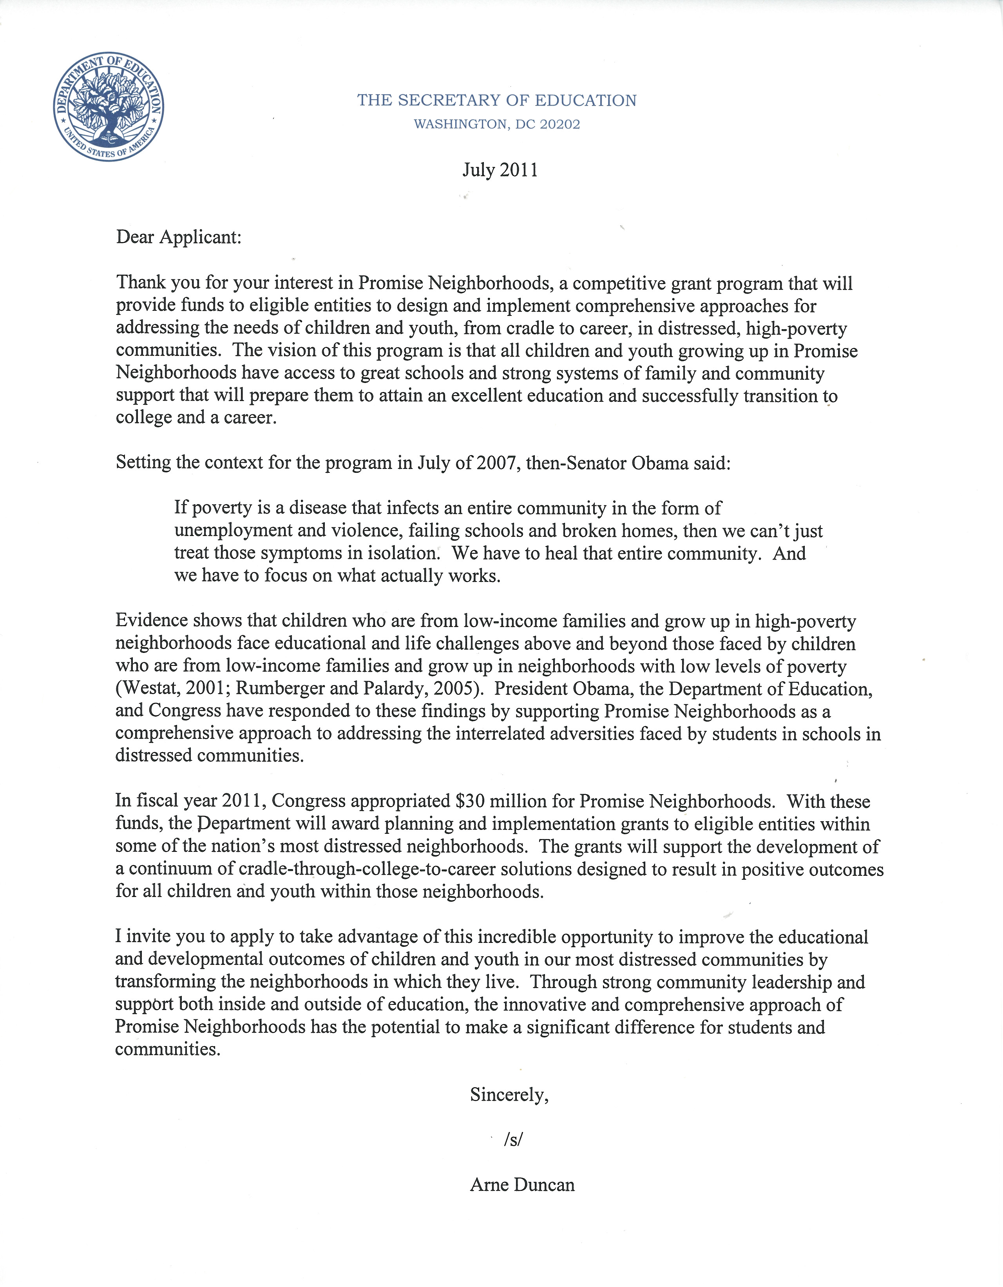
2011 Promise Neighborhoods At-A-Glance
Office of Innovation and Improvement, U.S. Department of Education
July 2011

In 2010, more than 300 communities from 48 states and the District of Columbia submitted applications for Promise Neighborhoods planning grants. Promise Neighborhoods support cradle-to-career services designed to improve educational and developmental outcomes for students in our country’s most distressed urban and rural neighborhoods. The Department of Education is pleased that Congress has appropriated nearly $30 million to support a new set of planning grants and implementation grants. In response to feedback from previous applicants and other stakeholders, the Department made changes to simplify and improve the 2011 planning competition, as well as conduct, for the first time, an implementation competition. The key changes and details on the grant competitions are included below. Prospective applicants should review the competition documents for the grant category in which they plan to apply in order to understand specific application requirements.
Key Changes: As a summary, the key changes include:
- Planning and Implementation Grants: The 2011 Promise Neighborhoods competition will be for both planning and implementation grants.

 | Implementation | Planning
Estimated Funding Available | Up to $23.5MM* | Up to $5MM
Estimated Number of Grants | 4-6 | 10
Estimated Size of Grants | $4MM - $6MM annually | $500K
Term | 3 years with the potential for an additional 2 years | 1 year
* the balance of funding ($1.5MM) will be used for national activities—technical assistance, evaluation, and peer review

- Absolute Priorities (APs): Like the 2010 competition, both the planning and implementation competitions in 2011 include a total of three Absolute Priorities (AP1 – Promise Neighborhoods Plan; AP2 – Rural Communities; and AP3 – Tribal Communities).

- Competitive Preference Priorities (CPPs): Applicants for both planning and implementation grants may identify no more than two CPPs for the purpose of earning competitive preference points. Applicants may address as many of the competitive preference priorities as they wish for the purpose of providing a comprehensive description of their proposed projects. However, the Department will only review and award points under a maximum of two CPPs the applicant identifies. The 2011 competition now includes four CPPs as noted below:
  - CPP 4 – Comprehensive Local Early Learning Network (2 points)
  - CPP 5 – Quality Internet Connectivity (1 point)
  - CPP 6 – Arts and Humanities (1 point)
  - CPP 7 – Quality Affordable Housing (partnership with the Department of Housing and Urban Development) (1 point)

- Additional Priorities:
  - Invitational Priority 8: The Secretary is interested in receiving applications with plans that are coordinated with adult education programs that provide training and opportunities for family members to support student learning. An application that meets this priority will not receive preference over other applications.
  - Optional Funding Opportunity: The Department of Justice intends to provide an optional, supplemental funding opportunity for Promise Neighborhoods implementation grantees with plans to significantly improve public safety in their neighborhoods.

- Selection Criteria: Compared to the 2010 Promise Neighborhoods competition, the selection criteria have been reduced and streamlined. In general, the criteria align with the priority requirements that applicants demonstrate need in the neighborhood, a strategy to build a cradle-to-career continuum, and the capacity to execute the strategy.

Priority Alignment | Selection Criteria | Planning Score | Implementation Score
Need | - Need for the Project | 15 | 15
Strategy | - Quality of the Project Design | 20 | 25
Strategy | - Quality of the Project Services | 20 | 15
Capacity | - Quality of the Management Plan | 45 | 45
 | Total Points | 100 | 100

- Matching Requirements: The percentage amount of match remains the same for planning applicants—50% of the grant award, which includes public and private sources. The match amount for implementation applicants is 100% of the grant award, which also includes public and private sources, and 10% of which must come from private sources. Rural and tribal applicants are only required to provide half of the match requirement (25% for planning grants and 50% for implementation grants). Federal agency contributions, under both competitions, can be used to meet the match.

Summary of FY11 Competition Design:
- Vision and Purpose: The vision of this program is that all children and youth growing up in Promise Neighborhoods have access to great schools and strong systems of family and community support that will prepare them to attain an excellent education and successfully transition to college and a career. The purpose of Promise Neighborhoods is to significantly improve the educational and developmental outcomes of children and youth in our most distressed communities, and to transform those communities by—
  - Identifying and increasing the capacity of eligible organizations that are focused on achieving results for children and youth throughout an entire neighborhood;
  - Building a complete continuum of cradle-through-college-to-career solutions of both educational programs and family and community supports, with great schools at the center;
  - Integrating programs and breaking down agency “silos” so that solutions are implemented effectively and efficiently across agencies;
  - Developing the local infrastructure of systems and resources needed to sustain and scale up proven, effective solutions across the broader region beyond the initial neighborhood; and
  - Learning about the overall impact of the Promise Neighborhoods program and about the relationship between particular strategies in Promise Neighborhoods and student outcomes, including through a rigorous evaluation of the program.
- Planning Grants would support eligible organizations that need to develop feasible plans to create a continuum of solutions with the potential to significantly improve the educational and developmental outcomes of children and youth in a neighborhood. These grants would support eligible organizations that demonstrate the need for implementation of a Promise Neighborhood strategy in the geographic areas they are targeting, a sound strategy for developing a feasible plan, and the capacity to develop the plan.
- Implementation Grants would support eligible organizations in carrying out their plans to create a continuum of solutions that will significantly improve the educational and developmental outcomes of children and youth in the target neighborhood. These grants would aid eligible organizations that have developed a plan that demonstrates 1) the need for implementation of a Promise Neighborhood in the geographic area they are targeting, 2) a sound strategy, 3) and the capacity to implement the plan. Specifically, grantees would use implementation grant funds to develop the administrative capacity necessary to successfully implement a continuum of solutions, such as managing partnerships, integrating multiple funding sources, and supporting the data system.
- Eligibility Requirements: Eligible organizations for both Promise Neighborhoods planning and implementation grants include: (1) nonprofit organizations, which may include faith-based nonprofit organizations, (2) institutions of higher education, and (3) Indian tribes.
- Timing: Application information for Promise Neighborhoods will be available Wednesday, July 6. Application submissions will be due on Tuesday, September 6. The deadline for the Department to make awards is December 31, 2011.
- Additional details may be found on the Promise Neighborhoods website: http://www2.ed.gov/programs/promiseneighborhoods/index.html
- Additional inquiries should be submitted to PN2011faq@ed.gov.

