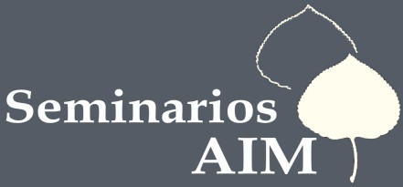
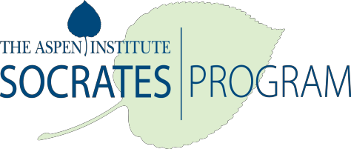

The Next Wave of Tech Innovation: What It Means for How We Live and Do Business

Moderator: William Powers

November 5-7
Puebla, Mexico

Seminar Location: Palafoxiana
(Address: Av. 5 Oriente 5, Centro Histórico, 72000 Heróica Puebla de Zaragoza, Pue., Mexico)
Hotel: Quinta Real
(Address: Calle 7 poniente 105, Colonia Puebla Centro, Puebla México 72000)

Thursday, November 5, 2015

  - Arrival and registration
  - 14:00 Shuttles from Mexico City to Puebla
  - 19:30 – 22:00 Dinner with a special speaker (TBD)

Friday, November 6, 2015

  - 10:00 – 14:00 Session I
  - 14:00 – 15:30 Lunch at Palafoxiana
  - 15:30 – 19:00 Session II
  - 19:30 Transport from hotel to town
  - 20:00 – 22:00 Dinner
  - 22:00 Gathering (hotel bar or bar in town)

Saturday, November 7, 2015

  - 10:00 – 14:00 Session III
  - 14:15 Closing Lunch
  - Ciudad de las Ideas Festival (1/2 Day Ticket)
Sunday, November 8, 2015

For participants staying in Puebla for the rest of the weekend, we have arranged an optional excursion to Cholula on Sunday, November 8th.

